**WORK INSTRUCTION FOR REVERSE CHARGING FOR FLUSHING OF ALKALI**

Responsibility: Shift superintendent /Control room Engineer/Furnace In charge

**Identified Hazards:**

1. Overfilling of charging hopper
2. Fall of material – caused by Overflow of material from overfilled receiving/charging hopper
3. Damage to charging system due to faulty commands
4. Faulty command being fed leading to undesired charging sequence
5. Unauthorized operation or repair of any equipment is a punishable offence.
6. In this method first coke is taken on lower bell and top of that ore is taken. With the weight of the metallic coke will tend to fall towards the periphery and this will help in peripheral movement of gas and cutting of jam and alkali flushing will be there.
7. Control room engineer to login with their password. Go to Page Table for PROD and select tab “LB FILLED WITH COKE+ORE OPEN PERMISSIVE” as shown in pic

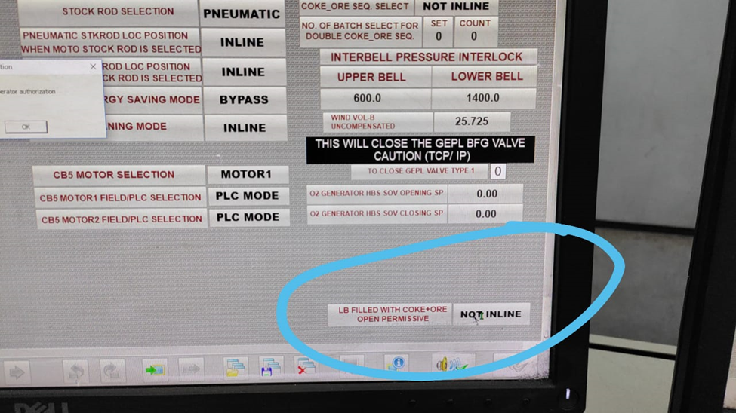

1. Frequency of this flushing charges will be as per below criteria

* After running special grade or after running basic grade production
* Grade changeover from special grade to foundry grade production

1. In this following needs to be ensured.

* This is to be continued 15-20 charges for 2 days
* Before starting dump level to at least increase by 0.5m. Coke base is adjusted such that total quantity of IBRM and COKE fits into inter bell space. One EC to be given at start of this process, in between the process and at the end of this process.
* Coke rate to be increased by 50 KG during this process of charging 15-20 reverse charges.
* One reverse flushing is completed click on deselect the tab of reverse flushing

1. Further increase of charging an extra coke during reverse coke charging sequence, decision to be taken depending upon furnace condition or by approval of HOD, Production

|  |  |  |
| --- | --- | --- |
| **Prepared By:**  Head – Production PID I | **Reviewed & Issued By:**  Management Representative | **Approved By:**  Head – Pig Iron Division |
| **Signature:** | **Signature:** | **Signature:** |
| **Date: 15.07.2022** | **Date: 15.07.2022** | **Date: 15.07.2022** |

|  |  |  |  |
| --- | --- | --- | --- |
| **Amendment Record** | | | |
| **Revision date** | **Manual Section ref. and para** | **Brief details of revision** | **New Revision No.** |
| 15.07.2022 | Reverse charging for flushing of Alkali | Change in format | 01 |